**HARDWARE IMPLEMENTATION OF DEEP LEARNING CONVOLUTIONAL NEURAL NETWORKS**

A Thesis

Presented to the

Faculty of

California State Polytechnic University, Pomona

In Partial Fulfillment

Of the Requirements for the Degree

Master of Science

In

Electrical Engineering

By

Mark A. Espinosa

2017

**SIGNATURE PAGE**

**THESIS:** HARDWARE IMPLEMENTATION OF DEEP LEARNING CONVOLUTIONAL NEURAL NETWORKS

**AUTHOR:** Mark A. Espinosa

**DATE SUBMITTED:** Spring 2017

Electrical and Computer Engineering Department

Dr. Zekeriya Aliyazicioglu

Thesis Committee Chair

Electrical & Computer Engineering

Dr. Rajan Chandra

Electrical & Computer Engineering

Dr. ???

???

If you choose to use a different font when typing your thesis, remember to change the font throughout your entire paper to match.

# ACKNOWLEDGEMENTS

Optional.

# ABSTRACT

Check with your department for abstract length.

**TABLE OF CONTENTS**

SIGNATURE PAGE ii

ACKNOWLEDGEMENTS iii

ABSTRACT iv

LIST OF TABLES vi

LIST OF FIGURES vii

MOTIVATION 1

STATE OF THE ART 2

SIMULATION 3

HARDWARE DEVELOPMENT 4

EXPERIMENTAL RESULTS 5

REFERENCES 6

APPENDIX A : Code Listing 7

If you need to add sections to your Table of Contents, you would add those sections throughout the document. For instance, if you were adding a subheading under Chapter 1 called “Introduction,” you would mark that as a “Heading 2” style under Styles. Then you could update your Table of Contents by right clicking the Table of the Contents, selecting “Update Field,” then selecting “Update entire table,” and then selecting OK.

You may need to change the font in the Table of Contents after doing an update, such as changing from all upper case to only the first letter of each word being upper case. To do so, select the text then use the Aa function next to your selection to change the letter case of a section of text. 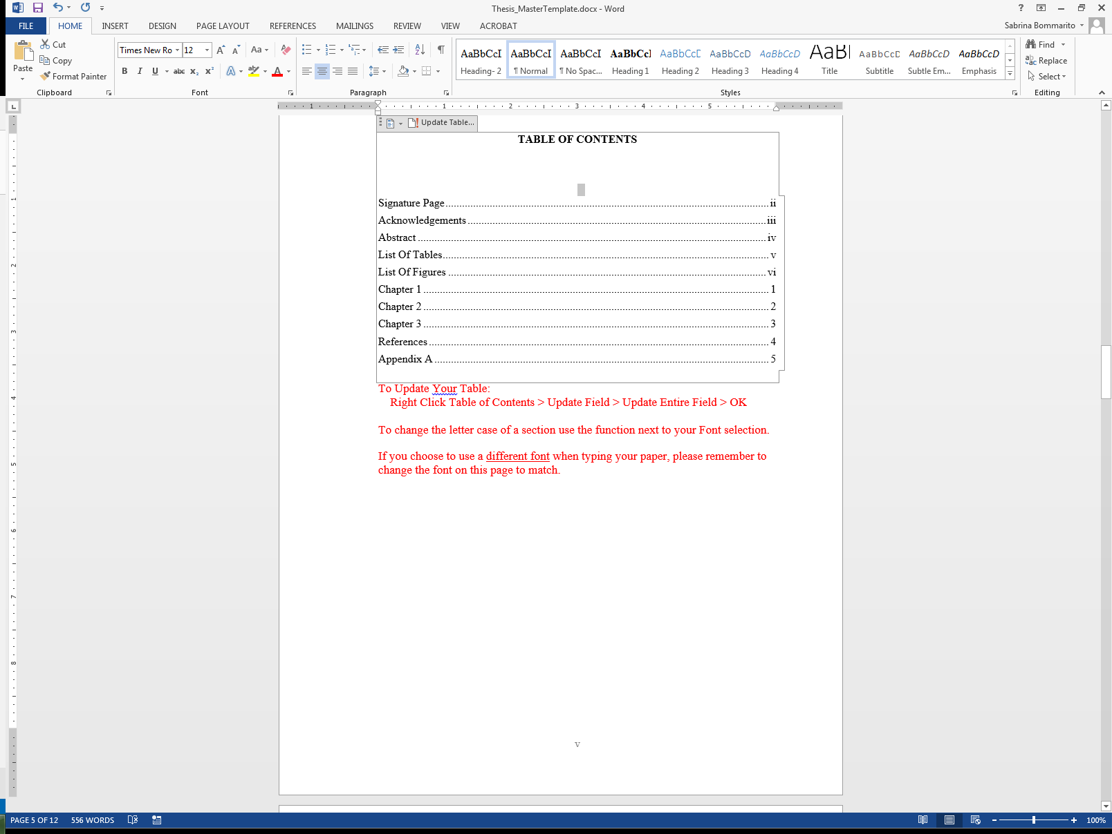 You may also notice that some bolded text appears in your Table of Contents after an update. You will need to also change this to regular font.

If you choose to use a different font when typing your paper, please remember to change the font on this page to match.

# LIST OF TABLES

Table 1. Effect of Humidity Showing Responses to Four Different Soil Textures 3

Table 2. Cost of BCZ Services Provided by BCZ Consulting Group 4

Table 3. Sample Table Including Confidence Intervals with Upper and Lower Limits 4

For the List of Tables to update properly you must use captions for your tables. Captions are titles or brief explanations for your table. To add captions, in your document body, right click your table(s), and select “Insert Caption.” A dialog box will open where you will input the title of your table. Next, in the drop down select “Type of Label.” Once you select the type of label, select the placement as either above or below the table and then click ok.

To update the List of Tables, you’ll need to be on this page listing all of the tables, not in the document body. First, right click the contents of the List of Tables, select “Update Field,” then select “Update entire field,” and then click OK. If you have used the captioning feature as suggested above, updating your List of Tables will automatically include captioned tables from your document.

Remember to make sure your captions meet your formatting criteria such as (APA, MLA, etc.) by changing font, font size, placement and alignment of caption text as necessary.

If you choose to use a different font when typing your paper, please remember to change the font on this page to match.

# LIST OF FIGURES

Figure 1. Food Supply Chain 2

Figure 2. Example of a Training Schedule for Year 2011-2012 2

Figure 3. Linear Relationship with Respect to Wafer Weight Loss and the Concentration of Zinc Iron 2

For the List of Figures to update properly you must use captions for your figures. Captions are titles or brief explanations for your figure. To add captions, in your document body, right click your figure(s), and select “Insert Caption.” A dialog box will open where you will input the title of your figure. Next in the drop down select “Type of Label.” Once you select the type of label, select the placement as either above or below the figure and then click ok.

To Update the List of Figures you’ll need to be on this page listing all of the figures, not in the document body. First, right click the contents of the List of Figures, select “Update Field,” then select “Update entire field,” and then click OK. If you have used the captioning feature as suggested above, updating your List of Figures will automatically include captioned figures from your document.

Remember to correct captions to meet your formatting criteria such as (APA, MLA, etc.) by changing font, font size, placement and alignment of caption text as necessary.

If you choose to use a different font when typing your paper, please remember to change the font on this page to match.

**MOTIVATION**

**STATE OF THE ART**

**SIMULATION**

**HARDWARE DEVELOPMENT**

**EXPERIMENTAL RESULTS**

# REFERENCES

# APPENDIX A: Code Listing

If you have more than one appendix, label them APPENDIX A, B, etc.